UNITY CONGRESSIONAL MAP 12/19/11 – QUEENS COUNTY THEATER
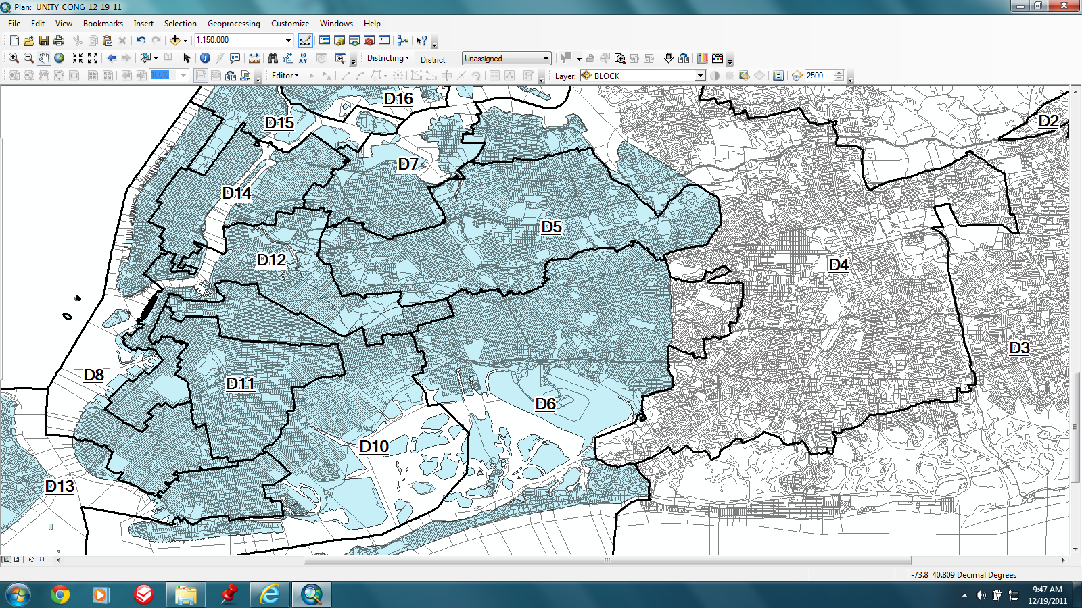

UNITY CONGRESSIONAL MAP 12/19/11 – KINGS COUNTY THEATER
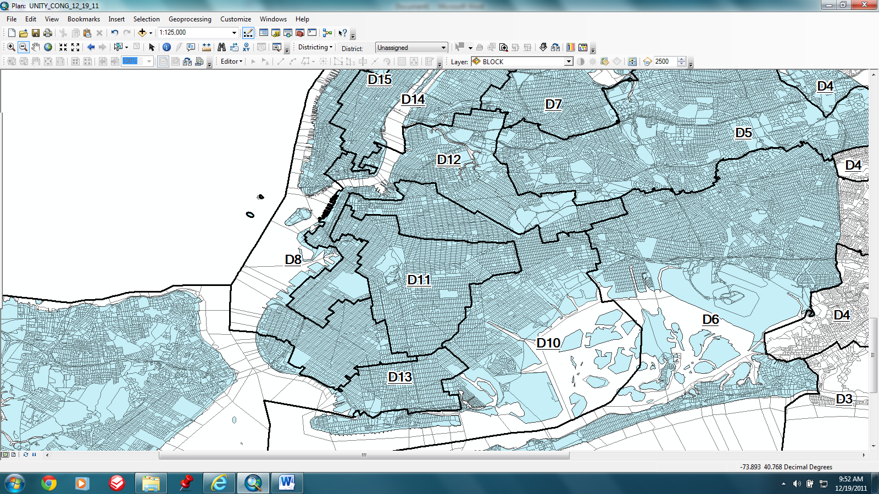

UNITY CONGRESSIONAL MAP 12/19/11 – BRONX/MANHATTAN/WESTCHESTER COUNTIES THEATER
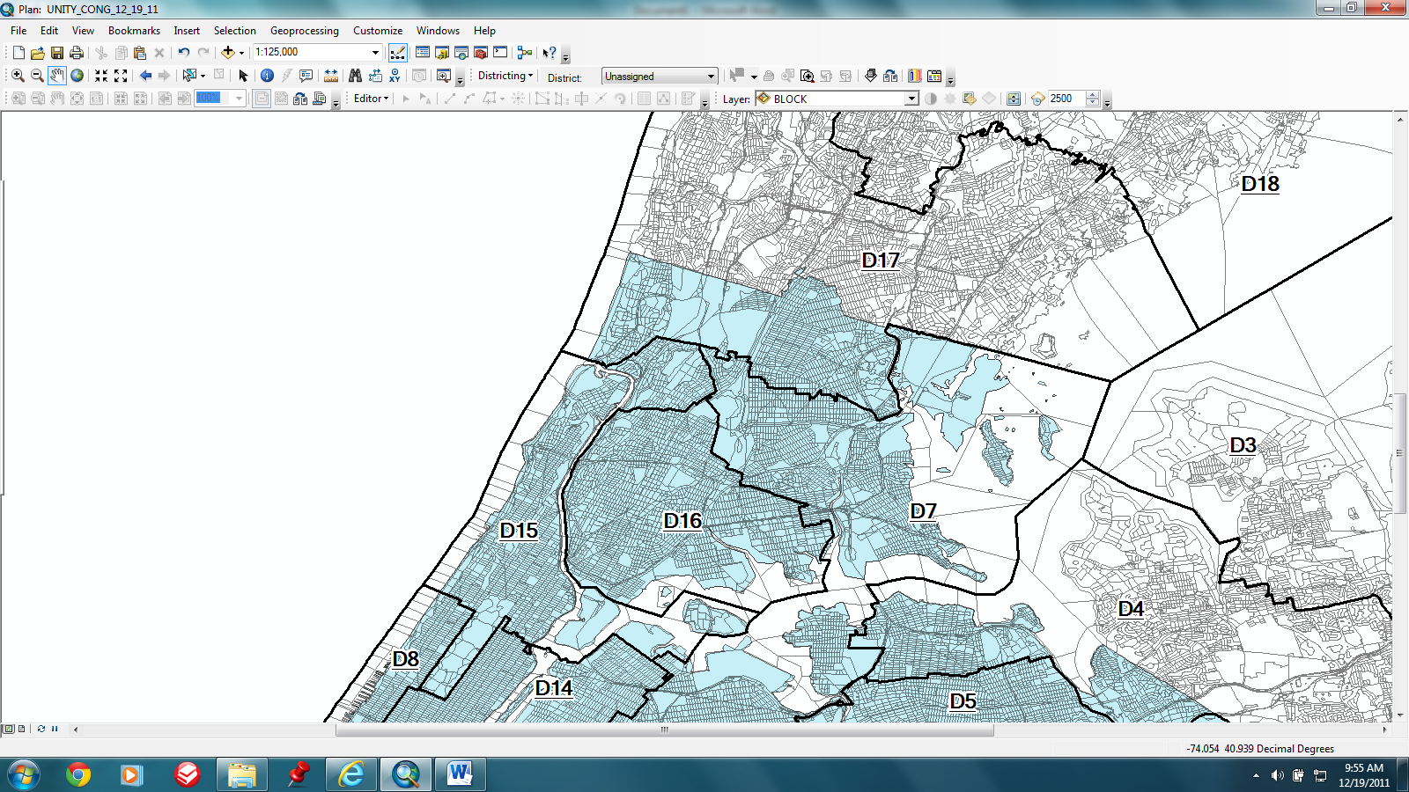
UNITY CONGRESSIONAL MAP 12/19/11 – BRONX/WESTCHESTER COUNTIES THEATER
